Pokhara University

Level: Bachelor | Semester – Spring | Year : 2005
Programme: BE |  | Full Marks : 100
Course: Electronic Devices |  | Time : 3hrs.

Candidates are required to give their answers in their own words as far as practicable.
The figures in the margin indicate full marks.

Attempt all the questions.

1. | - What is a non-linear model? Derive an expression and find the value of resistance r_{d} of a piece wise linear model of a silicon diode with I_{S} = 10⁻¹¹A & η = 1.6 at 1_{D} = 1mA. Also find the voltage source of the diode.  - Discuss the switching characteristics of a BJT and a Diode. | 2+2+2+2  7
2. | a) What is tunnelling phenomenon? How the tunnel diode operates? Write its applications in brief.  b) What is a voltage stabilizer? Differentiate between Avalanche and Zener breakdown.  c) Explain transistor as an inverter. Calculate the different transistor currents in the circuit below. Given β = 200.  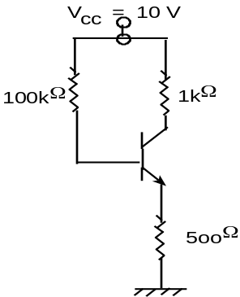 | 7  1+3  4
3. | - What is Fermi level? Derive an expression of Fermi level for n-type semiconductor.  - Draw the different configurations of a bipolar transistor with characteristic curves. Compare their input impedance, output impedance, voltage gain and current gain. Derive relation between α and β. | 7  3+3+2
4. | - Draw the circuit for emitter follower with voltage divider bias and explain how emitter resistor can provide bias stabilization against the variation of temperature.  - For the given two part network, derive the expressions for input impedance, output impedance, current gain and voltage gain.  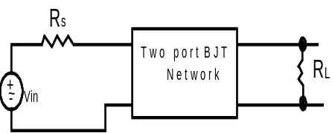 | 7  8
5. | a) For the given circuit, determine the input impedance and output voltage if Vs = 1 mV(rms). [Assume h_{ie} = 1.2 KΩ, h_{fe} = 100, h_{oe} = 2.5×10⁻⁵ S & h_{re} is neglible]  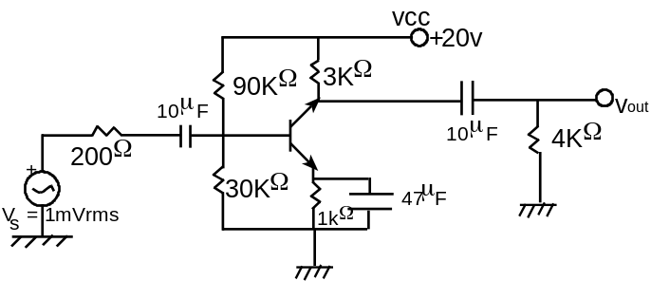  b) What is pinch-off voltage? Discuss its significance. Determine the following for the given circuit:  i) V_{GSQ} , I_{DQ} ii) V_{DS} iii) V_{S} iv) V_{G}  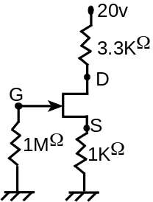 | 8  2+5
6. | a) Why BJT is said to be bipolar and JFET as unipolar? Write in brief. For the voltage divider network shown below, V_{D} =12v, V_{GSQ} = -2V. Determine the value of R_{S}.  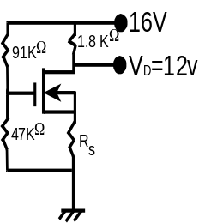  b) What is rectification process? How can you measure the effectiveness of the rectifier? Explain the types of filter circuits and their need at the output of a rectifier. | 6  9
7. | Write short notes on (Any Two):  - Clippers and Clampers  - Hot carrier diode  - UJT  - Silicon versus germanium | 2x5

